# HEX BARON – Class Diagram Tasks (MS)

# Task 1 (2 marks)

* 1 mark for completing the attributes correctly (as highlighted)
* 1 mark for completing the methods correctly (as highlighted)

A. Any order (it doesn’t have to be alphabetical)

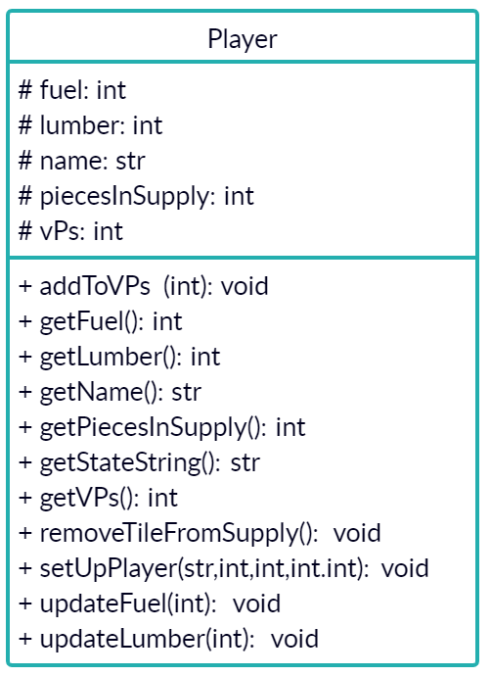

# Task 2 (5 marks)

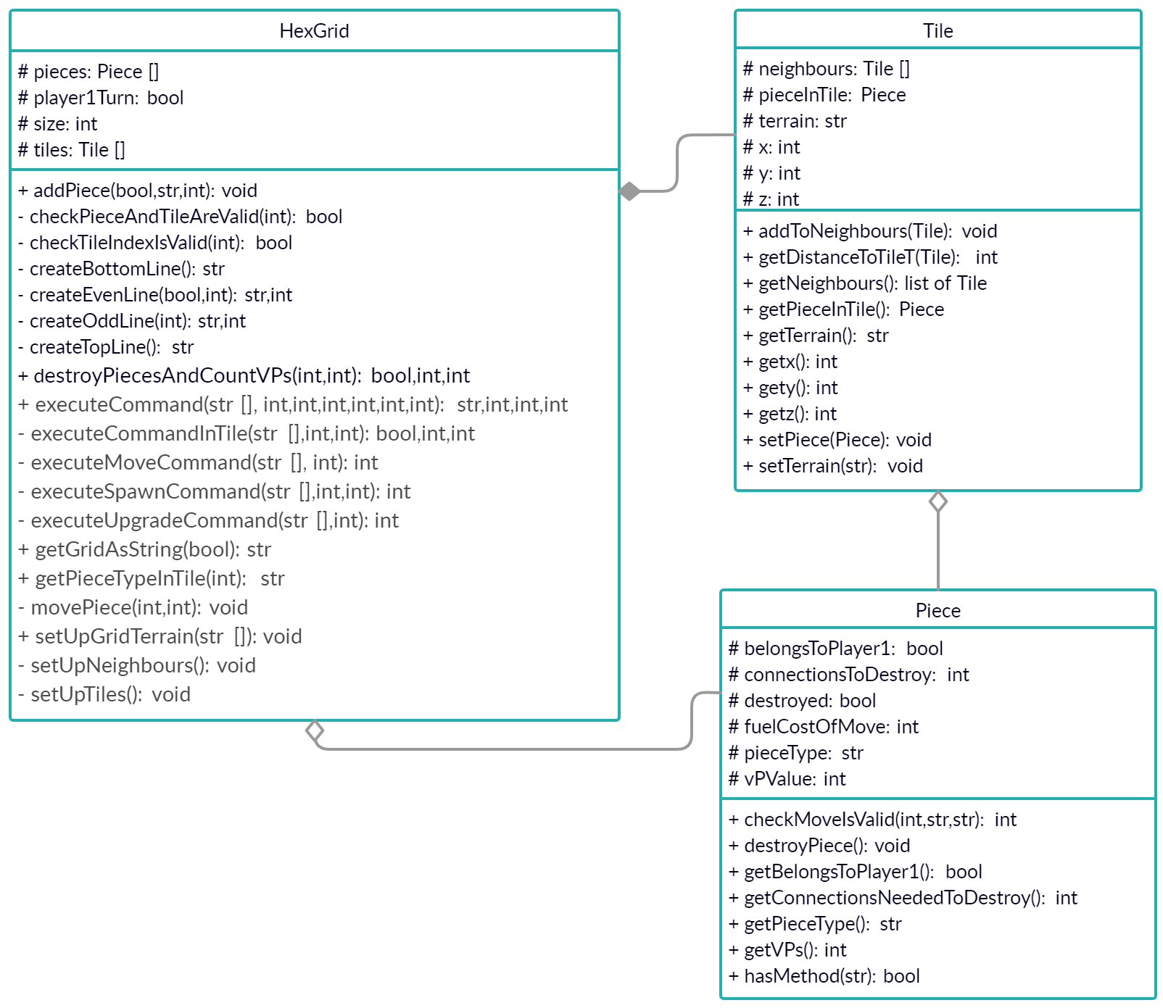

* 1 mark each for correctly completing the HexGrid and Tile classes
* 2 marks for correctly completing the Piece class (deduct 1 mark for a mostly correct attempt)
* 1 mark for adding the missing relationships

# Task 3 (4 marks)

* The constructors; because the convention is that they are not included (although some CASE tools include them for automatic code generation).

1 mark for naming constructors and 1 mark for the explanation

* Methods that override methods in their parent class; because the presence of the method (with the same name) in the child class means that it has overridden the method from the parent class (although some UML diagram tools use a <<override>> stereotype or similar).

1 mark for naming override (or overridden methods) and 1 mark for the explanation